Project Planning Phase
Project Planning Template (Product Backlog, Sprint Planning, Stories, Story points)

Team ID | PNT2022TMID01080
Project Name | Smart Solutions for Railways

Product Backlog, Sprint Schedule, and Estimation (4 Marks)

Sprint | Functional  Requirement (Epic) | User Story  Number | User Story / Task | Story Points | Priority | Team  Members
Sprint-1 | Registration | USN-1 | As a user, I can register for the ticket or query by entering my email, password and confirming my password. | 10 | High | Nivedhitha P
Sprint-1 |  | USN-2 | As a user, I will receive confirmation email or text message once I have registered for the ticket or query. | 10 | High | Nivedhitha P
Sprint-2 | Login | USN-3 | As a user, I can log into the application by entering email or user id & password. | 3 | Low | Sindu Mithra M.K
Sprint-2 | Dashboard | USN-4 | As a User, I can raise the issues or queries or feedback. | 8 | High | Sindu Mithra M.K
Sprint-2 |  | USN-5 | As a User, I can assure a safe journey by confirming all aspects of the railway system. | 4 | Low | Sindu Mithra M.K
Sprint-3 | Alerting through message | USN-6 | .As a User, I can receive message in the form of visual notification | 3 | Low | Monica S
Sprint-3 | Monitoring | USN-7 | As a User, I can able to monitor the cracks in the tracks through the use of sensors. | 8 | High | Monica S
Sprint-3 |  | USN-8 | As a User, I can monitor the communication and break system. | 4 | Low | Monica S
Sprint-4 | Maintenance | USN-9 | As an executive, I manage queries , upgrade & maintain the system and handle the troubleshoot accordingly. | 5 | Low | Swathi S
Sprint-4 | Administration  Work | USN-10 | As an Administrator, I can able to access and manage the data through the Cloud platform and make the necessary decisions as soon as possible. | 10 | High | Swathi S

Project Tracker, Velocity & Burndown Chart: (4 Marks)

Sprint | Total Story Points | Duration | Sprint Start Date | Sprint End Date (Planned) | Story Points  Completed (as on Planned End Date) | Sprint Release Date (Actual)
Sprint-1 | 20 | 6 Days | 24 Oct 2022 | 29 Oct 2022 | 20 | 29 Oct 2022
Sprint-2 | 15 | 6 Days | 31 Oct 2022 | 05 Nov 2022 | 20 | 05 Nov 2022
Sprint-3 | 15 | 6 Days | 07 Nov 2022 | 12 Nov 2022 | 20 | 12 Nov 2022
Sprint-4 | 15 | 6 Days | 14 Nov 2022 | 19 Nov 2022 | 20 | 19 Nov 2022

Velocity:
Imagine we have a 10-day sprint duration, and the velocity of the team is 20 (points per sprint). Let’s calculate the team’s average velocity (AV) per iteration unit (story points per day)
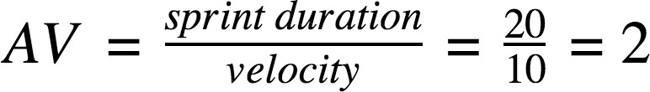

Burndown Chart:

A burn down chart is a graphical representation of work left to do versus time. It is often used in agile software development methodologies such as Scrum. However, burn down charts can be applied to any project containing measurable progress over time.
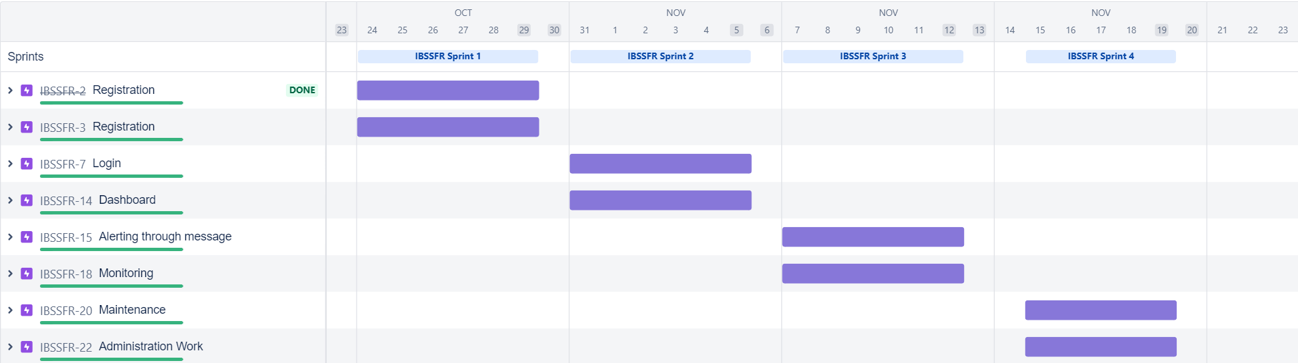

Reference:

https://www.atlassian.com/agile/tutorials/epics

https://www.atlassian.com/agile/tutorials/sprints

https://www.atlassian.com/agile/project-management

https://www.atlassian.com/agile/project-management/estimation

